(original by Jennifer Faith-Claspill, The Looped Group)

I have had Type 1 Diabetes for over 36 years. It is very well controlled and my most recent Hemoglobin A1C in June 2020 was 5.6%. To manage my diabetes effectively throughout the procedure today, there are a few important points to note.

- I am connected to an artificial pancreas, which is comprised of four physical pieces and 1 app on my iPhone. These pieces, along with the app, work together to keep my blood sugar within a safe range and should require no intervention by the medical team.

- You can watch my blood sugar in real-time at my Nightscout site: https://XXX.herokuapp.com as long as my iPhone and RileyLink are in close proximity to me during surgery. Nightscout will ONLY work if I am in range with my iPhone/RileyLink.

Artificial Pancreas Equipment:
I have a (1) Dexcom G6 Continuous Glucose Monitor (CGM), (2) an OmniPod Insulin Pump (aka “Pod”), and (3) a RileyLink. My Dexcom and OmniPod sites are both located on my left leg for today’s surgery.
My phone has (4) an app, called Loop, that takes the glucose readings from Dexcom G6 and makes temporary basal rate adjustments to keep me as close to my preset range as possible. RileyLink is the piece that sends the treatment decisions made by the app to my OmniPod. RileyLink is in a red case and attached to my iPhone. It is important to note that Loop ONLY works if my iPhone and RileyLink are within range of my body.

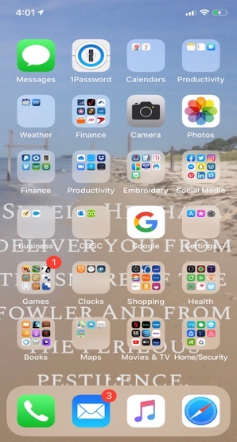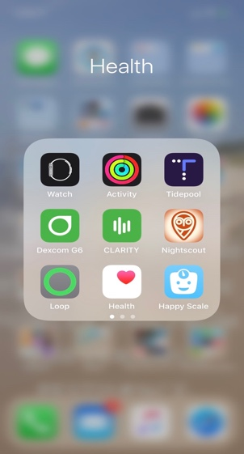
The Loop app should remain open at all times on my iPhone, but if it’s accidentally closed, you can find it on the first screen of my phone in the Health folder; look for the app with a green circle.

For today’s surgery, it is ok for me to run a little higher than normal. I have set my target blood sugar level on the Loop app to 115-120mg/dL, to offer a margin of safety during today’s procedure. To head off any hypoglycemia, I have been running a temporary basal since last night of 70% of my normal basal rates (pictured below). For today’s procedure, I am fine with my blood sugar running a little higher than normal.
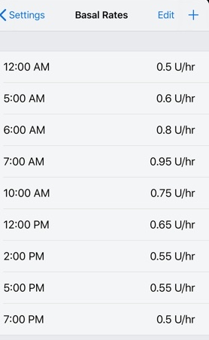
In the unlikely event that my blood sugar levels go below 70 mg/dL, you should administer a small amount of glucose (5g-10g) to bring me back up. Loop will automatically suspend all basal insulin delivery if I reach 75 mg/dL.

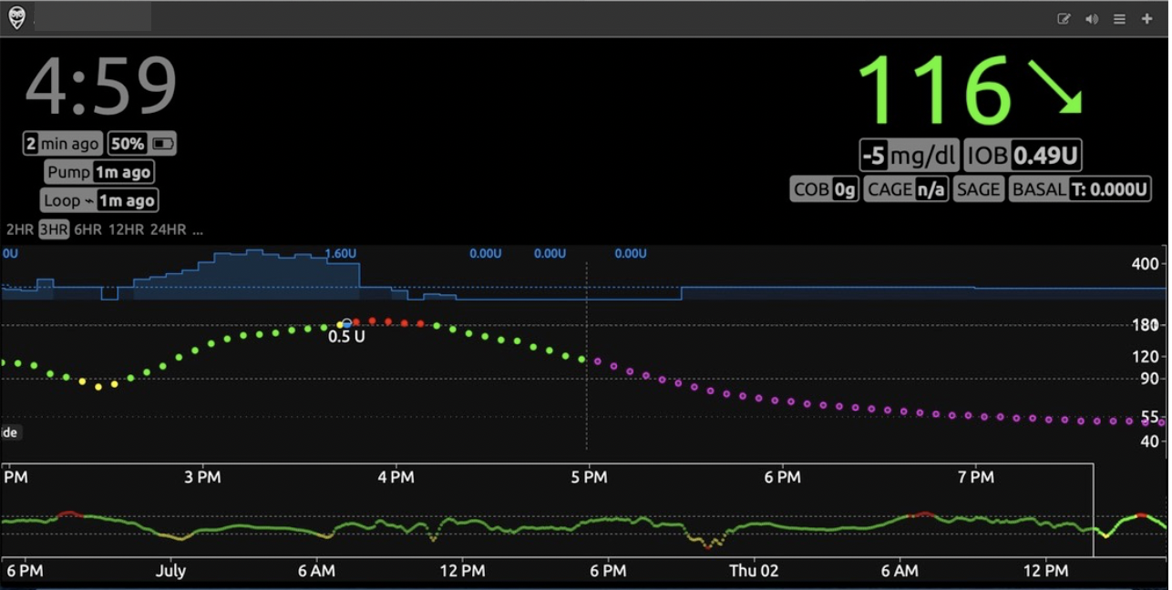
Nightscout
Nightscout allows you to view my glucose, insulin, and food/carb data real time with this website: https://XXX.herokuapp.com

Screenshot from Nightscout

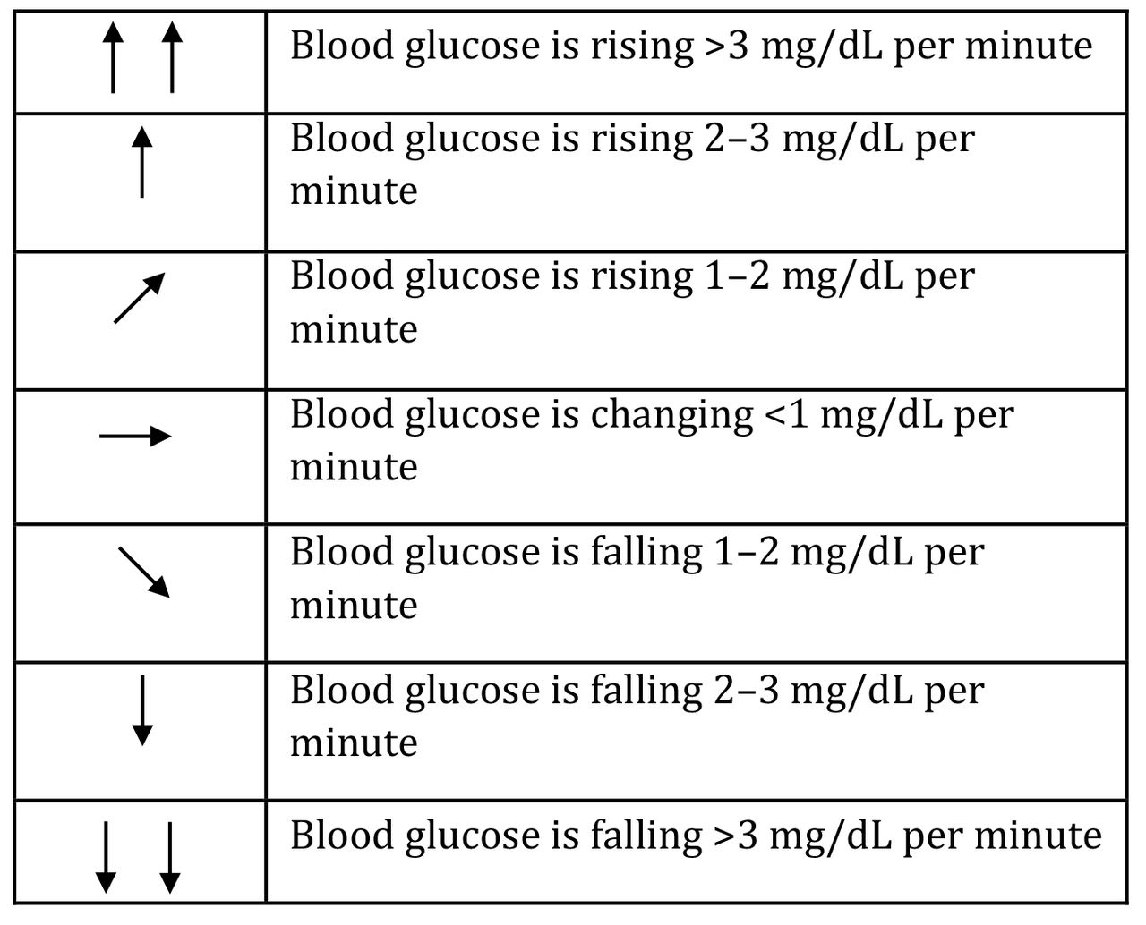
Screenshots from Dexcom & Omnipod
OmniPod with Novolog insulin
Dexcom G6 CGM
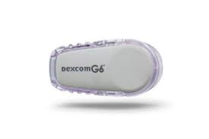
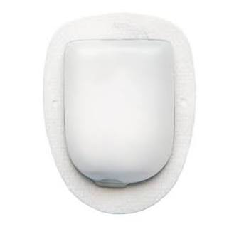

Dexcom G6 – What do the arrows mean?

CGM uses sensor glucose from interstitial fluid, which lags about 30 minutes behind blood glucose. While it is possible to have matching numbers between blood glucose and CGM, they generally will not match. Watch for the trending arrows on to see where I’ve been/where I’m headed. See above chart h

Loop App Information

More information on what the Loop app displays and what it all means can be found in Loop Docs:

https://loopkit.github.io/loopdocs/operation/loop-settings/displays/

Screenshot from Loop Docs
*edited to add Omnipod pics
